**Database Management System**

Semester Project

*Submitted BY:*

*Ahsan Wattoo (110765) & Nouman Hassan (110773)*

Submitted to : Maan sehrish

Project no 20:

20. Employee Time Tracking and Payroll with Overtime and Leave Deductions

Employees clock in/out using biometrics. Leaves are tracked by type (sick, casual, earned).

Payroll auto-calculates based on attendance, overtime, and late marks. Bonuses and

deductions are added. Payslips are generated monthly and emailed. HR can generate

headcount, attrition, and cost reports.

Entities And Attributes

1. Employee

(EmployeeID,Name,Email,Department,Designation,JoiningDate,Status)

2. Attendance

(AttendanceID,EmployeeID,Date,ClockInTime,ClockOutTime,LateMark,TotalHours,OvertimeHours)

3. Leave

(LeaveID,EmployeeID,LeaveType,StartDate,EndDate,Status)

4. Payroll

(PayrollID,EmployeeID,Month,BasicSalary,OvertimePay,Deductions,Bonuses,NetPay,PayslipURL)

5. Payslip

(PayslipID,PayrollID,GeneratedDate,EmailedTo)

6. 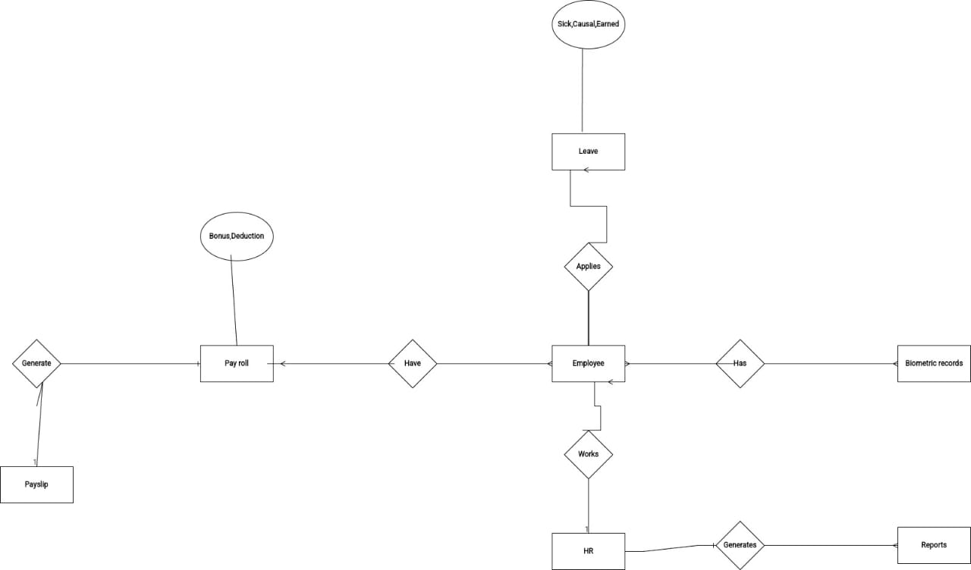

(ReportID,ReportType,GeneratedBy,GeneratedDate,FileURL)

Relationships:

Employee 1 — M Attendance

Employee 1 — M Leave

Employee 1 — M Payroll

Payroll 1 — 1 Payslip

HR/Admin 1 — M Report